# VIRTUAL MACHINE WITH GIVEN SPECIFICATIONS

**STEP – 1:**

Create a virtual machine.

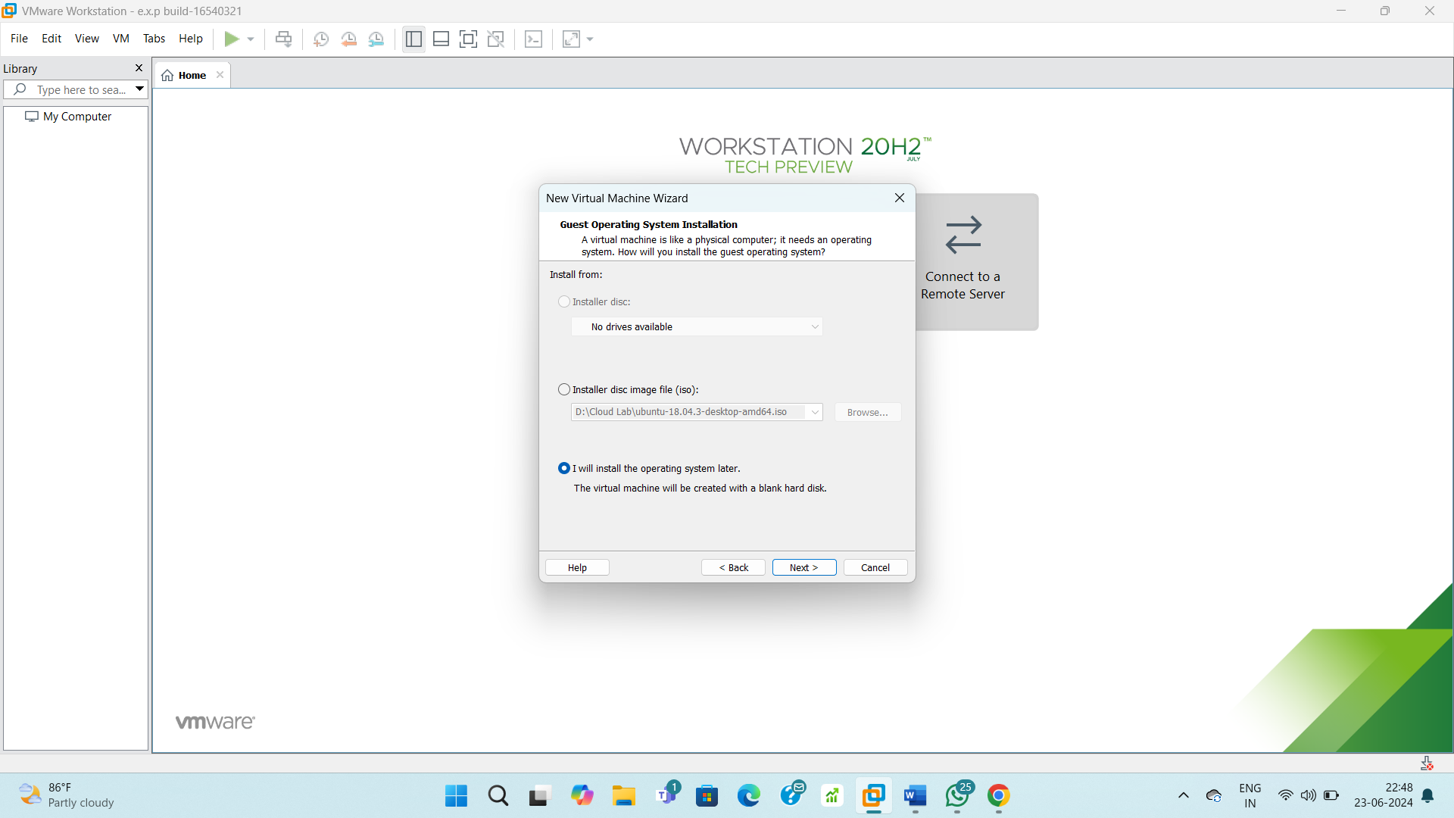

**STEP – 2:**

Use an OS.

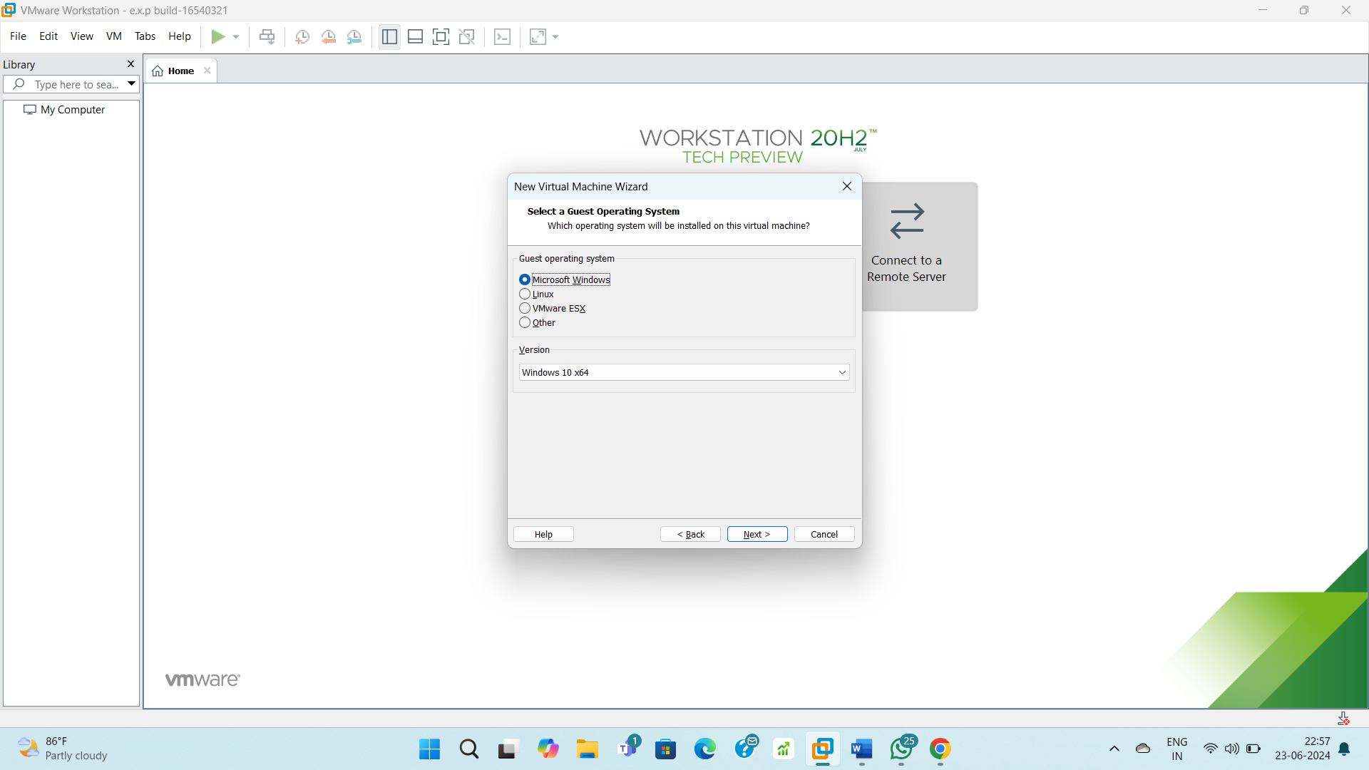

**STEP – 3:**

Allocate disk storage.

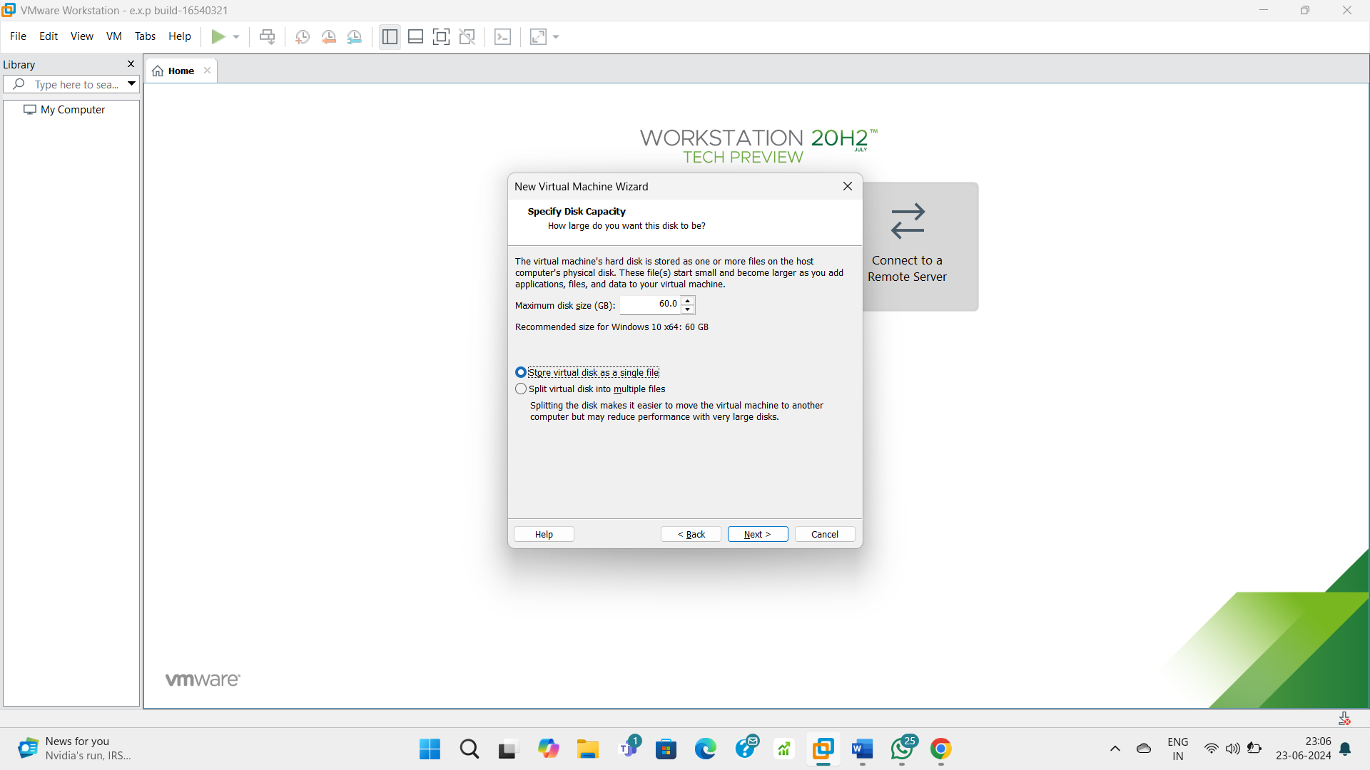

**STEP – 4:**

Check configurations.

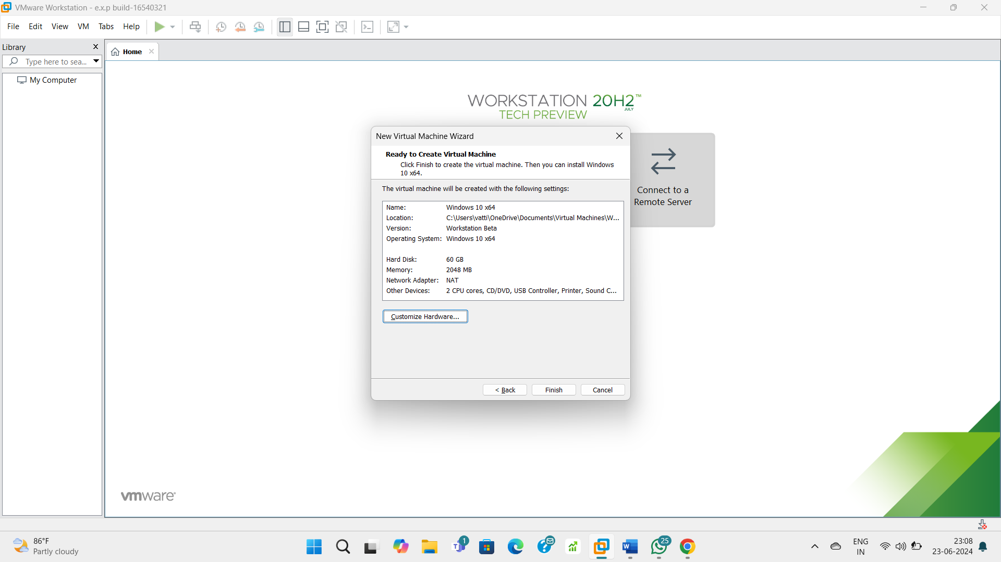

**STEP – 5:**

Configure the specifications.

